**Attendance Manager App**



**Session (2020-2024)**

**Program**

Bachelor of Computer Science

**Submitted By:**

Murad Ali Khan COMSC-F20-017

**Supervised by**:

**Syed Zulqarnain Shah**

Lecturer in Computer Science

GOVERNMENT POSTGRADUATE COLLEGE MANSEHRA

**DEPARTMENT OF COMPUTER SCIENCE**

**GOVT. POSTGRADUATE COLLEGE MANSEHRA**

**Attendance Manager App**



A report submitted to

Department of Computer Science

Government Postgraduate College Mansehra, HED, KP

As a partial fulfillment of requirements

For the award of the degree of

Bachelors of Computer Sciences from

Hazara University Mansehra

**DEPARTMENT OF COMPUTER SCIENCE**

**GOVERNMENT POSTGRADUATE COLLEGE MANSEHRA**

**FINAL APPROVAL**

This is to certify that we have read the thesis submitted by Murad Ali Khan. It is our judgment that this thesis is of sufficient standard to warrant it acceptances by the Department of Computer Science Government Post Graduate College Mansehra for the award of BS Computer Science Degree from Hazara University Mansehra.

1. External Examiner:  **__________________________________________**

Prof. Xyz

Professor & HOD of computer science

Government Postgraduate College No.1, Abbottabad.

1. Internal Examiner:**__________________________________________**

Mr. Xyz

Assistant Professor of computer science

Government Postgraduate College, Mansehra.

1. Supervisor: **__________________________________________**

Mr.Syed Zulqarnain Shah

Lecturer of Computer Science

Government Postgraduate College,Mansehra.

1. Head of Department: **__________________________________________**

Mr. Muhammad Abid

Assistant Professor of Computer Science

Government Postgraduate College,Mansehra.

**DEDICATION**

I would like to dedicate this thesis to my parents, whose unwavering support and love have been the foundation of my academic and personal achievements. Their guidance and encouragement have shaped me into the person I am today, and I am grateful for their sacrifices and belief in my abilities.

I also dedicate this work to my respected teachers, whose wisdom and expertise have played a crucial role in my educational journey. Their guidance and mentorship have not only imparted knowledge but also instilled in me a passion for learning and a drive for excellence.

**DECLARATION**

I hereby declare that this project neither as whole nor as a part has been copied from any source. It is further declared that I have developed this software and accompanied report entirely on the basis of our personal effort, under the sincere guidance of my supervisor, teachers. If any part of this system is proved to be copied out from any source or found to be reproduction of someone else, I shall stand by the consequences.

Name: Murad Ali Khan

Roll No: COMSC-F20-017

Signature: ____________________

**ACKNOWLEDGEMENT**

I would like to express my heartfelt gratitude to everyone who has contributed to the completion of this project.

First and foremost, I am grateful to the Almighty Allah for His blessings and guidance throughout this journey. His countless bounties have been the source of inspiration and strength.

I extend my deepest appreciation to my **dear parents**, whose unwavering love, support, and prayers have been instrumental in my success. Their encouragement and belief in me have motivated me to overcome challenges and reach new heights.

I am immensely thankful to my esteemed and dedicated supervisor, **Mr. Syed Zulqarnain Shah.** His invaluable guidance, insightful suggestions, and wholehearted cooperation have played a vital role in shaping this project. His expertise and encouragement have been a constant source of motivation.

**PROJECT IN BRIEF**

|  |  |
| --- | --- |
| **Project Title** | Attendance Manger App |
| **Organization** | Government Postgraduate College Mansehra |
| **Undertaken By** | Murad Ali Khan |
| **Supervised By** | Mr. Syed Zulqarnain Shah |
| **Starting Month** | November 2023 |
| **Ending Month** | Xyz 2024 |
| **Software Used** | Android Studio |
| **Environment Used** | Flutter, Dart, Firebase |
| **System Used** | Laptop(Thinkpad i5 6th Generation)  **PREFACE** |

This report explains all the detailed information from requirement analysis to testing and references. Each part is divided into different chapters along with complete details.

**Chapter 1: Introduction**

Introduction is the first chapter. In this chapter I will be sharing background of the project, existing system, system advantages and project modules etc. All this information will be mentioned in introduction of the project.

**Chapter 2: Existing System**

Existing System is the second chapter. In this chapter I’ll be sharing drawbacks and working of existing applications along with their data flow diagrams. The proposed solution to these problems will be shared as well.

**Chapter 3: Design of Proposed System**

It is the third chapter. In this chapter I will be sharing the design and implementation of the proposed system. The advantages and disadvantages will also be shared. Data flow diagram will also be presented to show the flow of the user in the application.

**Chapter 4: System Testing**

In this chapter I will be sharing the tools and techniques(methods) used to test the application. It includes the testing of the responsiveness, authentication testing and functionality testing as well.

**Chapter 5: Output of the System**

This is the fifth chapter, in this chapter I’ll be sharing the conclusion and outcomes of this project.

**Chapter 6: Conclusion and Future Work**

In this chapter, we will show the output of the system or the screen shots.

**ABSTRACT**

This thesis presents the development of a comprehensive Attendance Manager system consisting of two modules: Teachers and Administration. The Administration module is implemented as a web application using the Flutter framework, while Teacher modules are developed as Flutter mobile application. The primary goal of this project is to develop a centralized platform for efficient attendance management within educational institutions.

The Administration module is the core of the system, providing various features to help administrator manage attendance and other related tasks. It includes a dynamic dashboard that displays charts and summaries of the system's key metrics and modules. Administrator can register teachers, handle user accounts, and manage overall attendance records. They can also generate detailed reports, including teacher reports, which show how many subjects they handle and the number of classes they have taken in each subject. Subject reports indicate the number of students enrolled and the number of classes taken. Student reports display how many subjects a student is enrolled in and their attendance percentages. Finally, attendance reports for classes show the number of students and their attendance percentages.

The Teacher module, also a mobile application, allows teachers to register courses, manage subjects, add students, and mark attendance (Present, Absent, Leave). Teachers can also update or delete student information as needed. This module helps teachers keep accurate attendance records and provides an easy way to export student attendance data to Excel for reporting purposes.

Both modules are designed to work together, ensuring smooth data flow and communication between teachers and administrators. By using modern web and mobile technologies, the system provides a user-friendly and efficient experience for everyone involved.

This thesis documents the detailed design, development, and integration of the Attendance Manager system, highlighting its features, the technology stack used, and the benefits it offers to educational institutions. The evaluation of the system includes user feedback and performance analysis, showcasing its effectiveness in improving attendance management and overall administrative efficiency.

**CHAPTER NO 1**

# **INTRODUCTION**

# **1.1 Introduction of the Project**

Attendance management in educational institutions is a critical task that requires efficiency and accuracy. Manual attendance recording can be time-consuming and prone to errors, making it challenging for teachers and administrators to maintain accurate records. It is clear that a more efficient and automated system is needed to improve how we manage attendance.

The development of a comprehensive Attendance Manager system aims to address these challenges by automating the attendance recording process. This system not only reduces the burden on teachers and administrators but also provides real-time attendance tracking, automatic report generation, and efficient management of attendance data.

By implementing an Attendance Manager system, educational institutions can enhance their attendance management processes, leading to improved efficiency and accuracy in attendance tracking. This, in turn, can help boost overall productivity and ensure that attendance records are maintained accurately and efficiently.

The Attendance Manager system consists of two main modules: the Administration module and the Teacher module. The Administration module, developed as a web application using the Flutter framework, serves as the central hub for managing attendance-related tasks. This module includes features such as a dynamic dashboard for real-time monitoring, user account management, and detailed reporting functionalities.

Administrator can register teachers, manage user accounts, and maintain overall attendance records using the system. The module generates various reports, including teacher reports detailing the number of subjects taught and classes taken, subject reports indicating student enrollment and class attendance, and student reports showing subject enrollment and attendance percentages. Additionally, class attendance reports display the number of students present and their attendance percentages.

The Teacher module, developed as a Flutter mobile application, empowers teachers to efficiently manage attendance for their classes. Teachers can register new subject, manage subjects, add students, and mark attendance as Present, Absent, or on Leave. The module also allows teachers to update or delete student information as necessary, providing a seamless attendance management experience. Additionally, teachers can export attendance records to Excel for further analysis or reporting purposes. The module includes student profiles, showing their attendance status (Present, Absent, or on Leave) and attendance percentage for each subject. This feature enables teachers to monitor student attendance closely and identify any patterns or issues that may arise.

Both modules are designed to work in tandem, ensuring smooth data flow and communication between teachers and administrators. The use of modern web and mobile technologies enhances the user experience, making attendance management more accessible and efficient for all stakeholders.

This thesis documents the detailed design, development, and integration of the Attendance Manager system, emphasizing its features, the technology stack utilized, and the benefits it offers to educational institutions. The evaluation of the system includes user feedback and performance analysis, demonstrating its effectiveness in improving attendance management and overall administrative efficiency.

# **1.2 Background of the Project**

Managing attendance has always been a crucial aspect of the educational process. Teachers often face the challenge of manually recording attendance, which can be tedious and error-prone. The need for efficient and automated system to enhance the management of attendance processes has become evident.

The idea for the Attendance Manager app stemmed from these common challenges. Our goal was to create an app that simplifies attendance management for teachers. With this app, teachers can easily mark attendance and manage student records. The app also helps teachers identify attendance trends and provide support to students who may need it based on their attendance patterns.

Our Attendance Manager app is designed to provide a more organized and productive environment for teachers and administrators. By automating the attendance process, we aim to enhance the efficiency and accuracy of attendance tracking, ultimately benefiting educational institutions.

The system's two main modules – Administration and Teacher – work in tandem to ensure a seamless experience. The Administration module offers tools for managing overall attendance records, user accounts, and generating various reports. The Teacher module allows teachers to handle attendance tasks efficiently, manage student information, and monitor attendance patterns.

This thesis outlines the development and integration of the Attendance Manager system, showcasing its features, the technology used, and the advantages it brings to educational institutions. The project evaluation includes feedback from users and a performance analysis, highlighting the system's effectiveness in improving attendance management and administrative processes.

# **1.3 Advantages of the Project**

## The Attendance Manager system offers several advantages that significantly enhance the management of attendance in educational institutions. Here are some key benefits of implementing this system:

## **1.3.1 Improved Accuracy**

Manual attendance recording is prone to human errors, which can lead to inaccuracies in attendance records. The Attendance Manager system automates the attendance process, ensuring that records are accurate and up-to-date. This reduces the likelihood of errors and ensures that attendance data is reliable.

## **1.3.2 Time Efficiency**

Recording attendance manually can be a time-consuming task for teachers, especially when managing large classes. The Attendance Manager system streamlines this process, allowing teachers to quickly mark attendance and update student records. This saves valuable time that can be better spent on teaching and other important tasks.

## **1.3.3 Real-Time Tracking**

The Attendance Manager system provides real-time tracking of attendance, allowing administrators and teachers to monitor attendance patterns as they happen. This feature enables timely interventions for students who may have attendance issues and helps in identifying trends that may require attention.

## **1.3.4 Comprehensive Reporting**

One of the significant advantages of the Attendance Manager system is its ability to generate detailed reports. These reports include teacher reports showing subjects handled and classes taken, subject reports indicating student enrollment and class attendance, and student reports displaying subject enrollment and attendance percentages. Additionally, class attendance reports provide insights into the number of students present and their attendance percentages.

## **1.3.5 Enhanced Communication**

The Attendance Manager system ensures smooth data flow and communication between teachers and administrators. This seamless integration between the mobile and web module allows for better coordination and efficient management of attendance data. Teachers can easily update attendance records, and administrators can access this information in real time.

## **1.3.6 Data Security**

The Attendance Manager system ensures that attendance data is securely stored and protected. By using modern web and mobile technologies, the system safeguards sensitive information and prevents unauthorized access. This ensures that student attendance records are kept confidential and secure.

## **1.3.7 User-Friendly Interface**

The system is designed with a user-friendly interface, making it easy for teachers and administrators to navigate and use its features. The intuitive design of both the web and mobile applications ensures that users can quickly learn how to use the system effectively.

## **1.3.8 Scalability**

The Attendance Manager system is scalable, allowing it to accommodate the needs of different educational institutions regardless of their size. Whether it's a small school or a large university, the system can be customized and scaled to meet specific requirements.

## **1.3.9 Cost-Effective**

Implementing the Attendance Manager System can lead to cost savings in the long run. By reducing the need for manual attendance recording and minimizing errors, educational institutions can save on administrative costs and resources. The system's automated features also contribute to overall efficiency, reducing the workload on staff.

## **1.3.10 Better Student Engagement**

By providing accurate and up-to-date attendance records, the system helps in identifying students who may need additional support. Teachers can use this information to engage with students and address any attendance-related issues, leading to better student engagement and performance.

# **1.4 Project Modules**

The Attendance Manager system comprises two primary modules: Teacher and Admin. Each module is designed to cater to the specific needs of its users, providing a comprehensive solution for managing attendance and related tasks within educational institutions.

## **1.4.1 Teacher Module**

The Teacher module is developed as a mobile application using the Flutter framework. This module offers several features that streamline the attendance management process for teachers:

### **1.4.1.1 Authentication**

Teachers can securely log into the system using their credentials. The authentication process ensures that only authorized users can access the application's features.

### **1.4.1.2 Home Screen**

The home screen provides an overview of the subjects the teacher handles. It displays essential information about each subject, including the number of students enrolled and their attendance percentages.

### **1.4.1.3 Subject Management**

Teachers can register new subjects and add students to these subjects. Students can be added in three ways:

#### 1.4.1.3.1 Manually:

Teachers can manually input student details.

#### 1.4.1.3.2 Import from Existing Class:

Teachers can import student data from an existing class.

#### 1.4.1.3.3 Import from Excel Sheet:

Teachers can upload an Excel sheet containing student information.

### **1.4.1.4 Student Management**

Within each subject, teachers can manage student details. The module displays the number of students, their names, and their attendance percentages. Teachers can update or delete student information as needed.

### **1.4.1.5 Attendance Management**

Teachers can mark attendance for students, choosing from Present, Absent, or Leave. They can also update or delete attendance records if necessary. This feature ensures that attendance data is accurate and up-to-date.

### **1.4.1.6 Attendance History**

The module provides a history of attendance records for different dates. Teachers can review past attendance data and identify any trends or patterns. Additionally, attendance records can be exported to Excel for further analysis or reporting purposes.

### **1.4.1.7 Exporting Attendance Data**

Teachers have the option to export attendance data to Excel sheets. This feature is useful for generating reports and sharing attendance information with other stakeholders.

### **1.4.1.8 Comprehensive Management**

Overall, the Teacher module allows teachers to manage subjects, students, and attendance efficiently. The user-friendly interface ensures that teachers can quickly navigate through the app and perform their tasks seamlessly.

## **1.4.2 Admin Module**

The Admin module, developed as a web application using the Flutter framework, serves as the central hub for managing the entire attendance system. It includes all the functionalities of the Teacher module, along with additional administrative capabilities:

### **1.4.2.1 Authentication Management**

Administrators can accept or reject teacher accounts, ensuring that only authorized teachers can access the system.

### **1.4.2.2 Teacher Management**

Administrator has the ability to manage all teacher accounts. They can register new teachers, update their information, and handle user accounts effectively.

### **1.4.2.3 Subject Management**

Administrator can manage subjects across the entire institution. They can register new subjects, update existing ones, and oversee subject details for all teachers.

### **1.4.2.4 Student Management**

Similar to teachers, administrators can manage student information for all classes. They can add, update, or delete student records as needed.

### **1.4.2.5 Attendance Management**

Administrator can mark, update, and delete attendance records for all classes. This ensures that attendance data remains consistent and accurate across the institution.

### **1.4.2.6 Report Generation**

The Admin module includes robust reporting features, allowing administrators to generate various reports:

#### 1.4.2.6.1 Teacher Reports:

These reports show the number of subjects handled by each teacher and the number of classes they have taken in each subject.

#### 1.4.2.6 .2 Subject Reports:

These reports indicate the number of students enrolled in each subject and the number of classes taken.

#### 1.4.2.6.3 Student Reports:

These reports display how many subjects a student is enrolled in and their attendance percentages.

#### 1.4.2.6.4 Attendance Reports:

These reports provide insights into class attendance, showing the number of students present and their attendance percentages.

### **1.4.2.7 Dynamic Dashboard**

The Admin module features a dynamic dashboard that displays charts and summaries of key metrics and modules. This dashboard provides real-time monitoring of attendance data and helps administrators make informed decisions.

### **1.4.2.8 Comprehensive Management**

Overall, the Admin module allows administrators to manage teachers, subjects, students, and attendance effectively. The system ensures smooth data flow and communication between teachers and administrators, enhancing the overall efficiency of attendance management.

# **1.5 Introduction to the Tools:**

## **1.5.1 Android Studio:**

Android Studio is an Integrated Development Environment (IDE) specifically designed for Android app development. It provides a comprehensive set of tools and features that facilitate the creation, testing, and deployment of mobile applications.

## **1.5.2 Emulator and Device Support:**

It provides built-in emulators and support for testing apps on various Android devices, allowing developers to ensure compatibility and performance across different platforms.

## **1.5.3 Integration with Google Services:**

Android Studio seamlessly integrates with various Google services and APIs, enabling developers to leverage functionalities like Google Maps, Firebase, and Google Cloud Messaging.

## **1.5.4 Flutter Framework:**

Flutter is an open-source UI software development kit (SDK) developed by Google. It is specifically designed for building natively compiled applications for mobile, web, and desktop platforms from a single codebase.

Key features and benefits of Flutter include:

### **1.5.4.1 Cross-Platform Development:**

Flutter allows for cross-platform development, meaning that a single codebase can be used to create applications for both Android and IOS platforms. This significantly reduces development time and effort.

### **1.5.4.2 Hot Reload:**

Flutter offers a hot reload feature, which allows developers to see the changes made to the code in real-time, without the need to restart the application. This enables quick experimentation and iteration during the development process.

### **1.5.4.3 Rich UI Library:**

Flutter provides a rich set of customizable UI widgets that allow developers to create beautiful and responsive user interfaces. These widgets are designed to look and feel native on each platform, ensuring a consistent user experience.

### **1.5.4.4 High Performance:**

Flutter uses the Dart programming language and compiles the code to native machine code, resulting in high-performance applications. The framework also utilizes a GPU-accelerated rendering engine, enabling smooth animations and transitions.

### **1.5.4.5 Access to Device APIs:**

Flutter provides access to a wide range of device APIs and third-party integrations, allowing developers to leverage various device features and services. In the context of the attendance manager app, this includes the ability to read from and write to Excel sheets for importing and exporting attendance data. By integrating these capabilities, the attendance manager app ensures a smooth and effective user experience, facilitating the easy management of attendance data.

### **1.5.4.6 Active Developer Community:**

Flutter has a vibrant and active developer community, which means ample resources, documentation, and community support are available. This fosters knowledge sharing and helps developers overcome challenges more effectively.

# **1.6Firebase:**

Firebase is a powerful backend platform provided by Google, offering a wide range of services to support the development of web and mobile applications. This section highlights the integration of Firebase into the attendance manager app, specifically focusing on the services of Firebase Authentication and Firestore Database.

## **1.6.1 Firebase Authentication:**

Firebase Authentication enables secure user authentication and provides a seamless sign-up and sign-in experience for app users. It allows users to register and log in to the app using their email and password, Google account, or other authentication providers. This service ensures that user data is protected and accessible only to authorized individuals. In the context of the attendance manager app, Firebase Authentication helps manage user accounts for teachers, and administrators, ensuring that only authorized users can access the app and its features.

## **1.6.2 Firestore Database:**

Firestore Database is a No SQL cloud database offered by Firebase. It provides a flexible and scalable solution for storing and managing app data. In the attendance manager app, Firestore Database is utilized to store information about student attendance records, class schedules, user profiles, and other relevant data. This allows for efficient retrieval and manipulation of data, ensuring smooth app performance and real-time updates.

The integration of Firebase services adds robustness and functionality to the attendance manager app. Firebase Authentication ensures secure user authentication, while Firestore Database facilitates efficient data management. This combination of services enhances the overall performance, user experience, and data management capabilities of the attendance manager app

# **1.8 Scope of the Project**

The scope of this Attendance Manager project encompasses the development and implementation of a comprehensive mobile application and web app specifically designed for managing student attendance in educational institutions. The project aims to provide a user-friendly platform that offers essential tools and features to streamline attendance management for teachers and administrator. The key aspects of the project's scope include:

## **1.8.1 Mobile Application**

The mobile application will be developed using Flutter, catering to both Android and IOS users. It will serve as the primary interface for teachers to manage attendance, register subjects, and add students. The app will feature a user-friendly design, intuitive navigation, and interactive elements to facilitate easy attendance management and reporting.

## **1.8.2 Web Application**

The web app will be developed using Flutter and will serve as an administration tool for the institution's admin. It will enable administrators to manage and update teacher accounts, subjects, and student information. The web app will ensure real-time updates, allowing users to access the latest information and enhancing the system's efficiency.

## **1.8.3 Subject Management** Subject Management involves various tasks such as registering new subjects, updating existing subject details, and ensuring consistency and accuracy in subject information. Teachers are responsible for registering new subjects and making necessary updates to existing ones, ensuring that the subject details are up-to-date and accurate.

## **1.8.4 Student Management**

Student Management involves adding students to classes either manually or by importing them from existing classes or Excel sheets. Teachers also have the responsibility to update or delete student records as required. Additionally, they can view student details such as the total number of students, their names, and attendance percentages.

**1.8.5 Attendance Management**

Attendance Management allows teachers to mark students as Present, Absent, or on Leave during classes. They can also update or delete attendance records as needed. Furthermore, teachers can review past attendance records and export them to Excel for reporting purposes.

## **1.8.6 Report Generation**

Report Generation involves generating various types of reports for monitoring and evaluation purposes. Teacher reports include information on the number of subjects handled by each teacher and the number of classes taken. Subject reports provide insights into the number of students enrolled and classes taken for each subject. Student reports offer details on the subjects a student is enrolled in and their attendance percentages. Attendance reports comprise class attendance data, including the number of students present and their attendance percentages.

# **1.9 Feasibility**

A feasibility study is essential to evaluate the viability and potential success of a project. In the context of the Attendance Manager project, let's assess its feasibility based on the following factors:

## **1.9.1 Technical Feasibility**

The project involves the development of a mobile application and web app using Flutter and Firebase backend. These technologies are widely used, well-documented, and supported, ensuring technical feasibility. The availability of skilled developers and resources further supports the technical feasibility of the project.

## **1.9.2 Economic Feasibility**

The economic feasibility of the project primarily depends on the potential return on investment (ROI) and cost savings for educational institutions. By offering a comprehensive and user-friendly platform, the project can attract a large user base, leading to potential revenue generation through subscriptions, partnerships with educational institutions, and premium services. Conducting a thorough market analysis and revenue projection can provide a clearer picture of the project's economic feasibility.

## **1.9.3 Operational Feasibility**

Operational feasibility focuses on the project's practicality and ease of implementation. The project involves the development of a mobile application and web app, along with the integration of various services. The availability of skilled developers and the use of established technologies make the implementation process feasible. Additionally, the project can leverage existing databases and APIs for information and services, reducing the need for extensive data collection and management.

## **1.9.4 Legal and Ethical Feasibility**

When developing an attendance management app, it is essential to consider legal and ethical factors. This includes ensuring compliance with data protection regulations, respecting user privacy, and obtaining necessary permissions for using third-party services or data. By adhering to legal and ethical standards, the project can demonstrate its feasibility in terms of meeting regulatory requirements and maintaining user trust.

Based on the assessment of technical, economic, operational, and legal/ethical factors, the Attendance Manager project shows promising feasibility. However, it is important to conduct further research, market analysis, and validation to assess the project's feasibility in greater detail. This feasibility study serves as an initial assessment and should be complemented by a comprehensive analysis before proceeding with the project implementation.

### **Chapter 2**

# **Existing System**

**2.1 Introduction**

The existing system for managing attendance in educational institutions is crucial for keeping track of student attendance records. In this chapter, we will thoroughly analyze the current systems and approaches that are being used. We aim to understand their functionalities, strengths, weaknesses, and limitations. By examining the existing system, we can identify areas for improvement and lay the foundation for our proposed solution in the following chapters.

In many schools, attendance is managed using traditional methods such as paper registers and manual entry. Teachers call out names and mark students present or absent on paper sheets. These records are then compiled and reviewed by administrators to monitor attendance and identify patterns.

However, the existing system has several limitations that reduce its effectiveness and efficiency. One major drawback is the reliance on manual processes, which are time-consuming and prone to errors. Paper records can easily become lost or damaged, making it difficult to maintain accurate and reliable attendance data. Additionally, accessing and analyzing these records can be challenging, especially when real-time data is needed.

Given these limitations, there is a pressing need for a more efficient, comprehensive, and user-friendly system that leverages technological advancements to improve attendance management. In the following chapters, we will propose and develop a robust and innovative solution that addresses these limitations and provides an accurate, timely, and easy-to-use attendance management experience for teachers and administrators.

# **2.2 Overview of the Existing System**

In this section, we provide a detailed overview of the existing systems that are currently used to manage attendance in educational institutions. These systems include a variety of components and processes aimed at recording and maintaining student attendance. By understanding the functioning of the existing systems, we can identify their strengths, weaknesses, and areas that need improvement.

Many schools and colleges still rely on traditional methods such as paper registers and manual entry for attendance management. Teachers call out names and mark students present or absent on paper sheets. These records are later compiled by administrators to monitor overall attendance and identify patterns.

In addition to manual systems, some institutions use software-based solutions such as barcode scanners and biometric devices. Barcode scanners involve scanning student ID cards, while biometric devices use fingerprints or facial recognition to record attendance. However, these existing systems often come with several limitations. For example, some systems require heavy hardware investments and are expensive to implement and maintain. Barcode scanners require students to carry their ID cards at all times, which can be easily lost or forgotten. Biometric devices, on the other hand, raise concerns about hygiene and data privacy, in addition to being costly. These systems might use local hosting, which can lead to hardware failures and data loss. Moreover, many existing apps do not offer comprehensive functionalities like administrative controls, which are essential for effective attendance management

# **2.3 Limitations of the Existing System**

The existing attendance management systems, though useful, have several limitations that hinder their effectiveness. Here are some of the main drawbacks:

## **2.3.1 Costly Implementation:**

Many existing attendance systems, including biometric devices, require expensive hardware and software to function properly. This high cost makes it difficult for schools with limited budgets to adopt such systems. The need for dedicated servers and maintenance further adds to the financial burden.

## **2.3.2 Hardware Dependence:**

Systems that rely on local hosting are prone to hardware failures. If the server crashes or the hardware malfunctions, it can lead to data loss or downtime. This dependence on physical infrastructure makes the system less reliable and increases the risk of data unavailability.

## **2.3.3 Limited Functionality:**

Some existing systems do not provide all the necessary features for efficient attendance management. For instance, they might lack an admin module that allows for centralized control and oversight. Without such functionalities, managing attendance data becomes cumbersome and less effective.

## **2.3.4 Outdated Technology:**

Many traditional systems still use outdated technology, which limits their efficiency and scalability. They might not integrate well with other modern tools and systems used in educational institutions, leading to fragmented data and inefficiencies.

## **2.3.5 Lack of Real-Time Updates:**

Existing systems often do not provide real-time updates, which are crucial for timely decision-making. Without real-time data, teachers and administrators might not be able to address attendance issues promptly, affecting overall student management.

## **2.3.6 Hygiene and Privacy Concerns**

Biometric devices, while efficient, can raise hygiene concerns, especially in a school environment where multiple students use the same device. Additionally, there are privacy issues related to the storage and use of biometric data, which can be sensitive.

# **2.4 Comparative Analysis**

In this section, we conduct a comparative analysis of the existing systems used for attendance management in educational institutions. The purpose of this analysis is to evaluate the strengths and weaknesses of different systems and identify areas where improvements can be made. By understanding the existing landscape, we can better design and develop a more effective and user-friendly Attendance Manager App.

To conduct the comparative analysis, we consider various factors and criteria that are crucial for a successful attendance management system. These factors include:

## **2.4.1 Cost and Implementation**

We examine the cost implications and ease of implementation of existing systems. This includes evaluating the initial setup costs, ongoing maintenance expenses, and the complexity of integrating these systems into the existing infrastructure of educational institutions. Systems that are cost-effective and easy to implement have a significant advantage.

## **2.4.2 Reliability and Data Security**

We assess the reliability and data security offered by different systems. This includes evaluating the stability of the systems, the likelihood of hardware failures, and the measures in place to protect sensitive attendance data. Systems that ensure high reliability and robust data security are preferred.

## **2.4.3 Functionality and Features**

We investigate the range of functionalities and features provided by existing systems. This includes evaluating whether the systems support essential features such as real-time updates, admin control, reporting tools, and user management. Comprehensive systems with a wide array of features are more effective in managing attendance.

## **2.4.4 User Experience**

We evaluate the overall user experience offered by different systems. This includes assessing the user interface design, navigation, ease of use, and responsiveness of the systems. Systems that provide a user-friendly experience for both teachers and administrators are more likely to be adopted and effectively utilized.

By conducting a thorough comparative analysis, we gain insights into the strengths and weaknesses of existing systems, which guide us in developing a more robust and innovative Attendance Manager App. The aim is to leverage technology and address the limitations identified in the existing systems, providing educational institutions with an enhanced and comprehensive platform to manage attendance efficiently and securely.

## **2.5 Evaluation of Existing System**

In this section, we evaluate the existing systems used for attendance management in educational institutions. The purpose of this evaluation is to assess the effectiveness, efficiency, and suitability of these systems in meeting the needs of teachers, administrators, and students, as well as addressing the challenges faced by educational institutions. To conduct the evaluation, we employ various methods and techniques, including user surveys, expert interviews, and system performance analysis. These methods allow us to gather quantitative and qualitative data to assess the strengths and weaknesses of the existing systems.

We evaluate the existing systems based on the following criteria:

## **2.5.1 Usability**

We assess the ease of use and user-friendliness of the existing systems. This includes evaluating the navigation structure, clarity of instructions, and intuitiveness of user interfaces. A system that is easy to use and navigate contributes to a positive user experience for both teachers and administrators.

## **2.5.2 Functionality**

We analyze the functionalities provided by the existing systems. This includes assessing the range of features and services offered, such as real-time attendance tracking, reporting tools, admin controls, and integration capabilities with other educational tools. A comprehensive and well-functioning system enhances the overall management of attendance.

## **2.5.3 Performance**

We evaluate the performance of the existing systems in terms of response time, reliability, and scalability. This includes analyzing the system's ability to handle concurrent users, deliver information in a timely manner, and maintain stability under varying loads. A high-performing system ensures a seamless and efficient user experience, minimizing downtime and errors.

## **2.5.4 Reliability**

We assess the reliability and accuracy of the attendance data provided by the existing systems. This includes evaluating the consistency of data records, the security measures in place to protect data, and the frequency of updates. A reliable system instills trust in users and ensures that attendance records are accurate and up-to-date.

Based on the evaluation, we identify the strengths and weaknesses of the existing systems and determine the areas that require improvement. The findings from this evaluation serve as valuable insights for the design and development of our proposed Attendance Manager App, enabling us to address the shortcomings of the existing systems and provide a more effective and user-centric solution.

# **2.6 Functional and Non-Functional Requirements**

In this section, we identify and outline the functional and non-functional requirements of our proposed Attendance Manager App. These requirements serve as the foundation for the design and development of the system, ensuring that it meets the desired objectives and user expectations.

## **2.6.1 Functional Requirements**

Functional requirements define the specific features, functionalities, and capabilities that the Attendance Manager App should possess. These requirements are derived from the needs of the users and the objectives of the project. The functional requirements of our app include:

### **2.6.1.1 User Registration and Authentication**

The app should allow users to create accounts, log in securely, and manage their profiles. This ensures personalized experiences and enables access to additional features.

### **2.6.1.2 Attendance Tracking**

The app should provide tools for tracking student attendance in real-time. Teachers should be able to mark attendance easily, and students should be able to view their attendance records.

### **2.6.1.3 Admin Dashboard**

The app should include an admin dashboard for school administrators to manage attendance data, generate reports, and monitor overall attendance trends.

### **2.6.1.4 Reporting Tools**

The app should offer comprehensive reporting tools that allow users to generate attendance reports based on various criteria such as date ranges, class, and individual student records.

### **2.6.1.5 Data Export**

The app should enable users to export attendance data to common file format like XLS for external use and record-keeping.

## **2.6.2 Non-Functional Requirements**

Non-functional requirements define the quality attributes and constraints that govern the performance, usability, security, and reliability of the app. These requirements focus on the overall user experience and system behavior. The non-functional requirements of our app include:

### **2.6.2.1 Performance**

The app should deliver fast response times, ensuring quick loading of information and smooth navigation even under high user loads.

### **2.6.2.2 User Interface and User Experience**

The app should feature an intuitive and visually appealing user interface, providing a seamless and enjoyable user experience.

### **2.6.2.3 Security and Privacy**

The app should prioritize the security of user data, implement encryption measures, and adhere to privacy regulations to protect user information.

### **2.6.2.4 Scalability**

The app should be designed to accommodate increasing user demand and handle a growing database of student attendance records.

### **2.6.2.5 Compatibility**

The app should be compatible with various devices and operating systems, ensuring accessibility for a wide range of users.

### **2.6.2.6 Reliability and Availability**

The app should be reliable, with minimal downtime or system failures, ensuring uninterrupted access to information and services.

By defining both functional and non-functional requirements, we establish a clear set of objectives and criteria for the design and development of our Attendance Manager App. These requirements will guide the subsequent stages of the project, ensuring that the final product meets the needs of users and delivers a high-quality experience.

­­­­­­­­­­­­­­

# **Chapter 3**

# **Design of the Proposed System**

# **3.1 Introduction**

In this chapter, I will present the detailed design of the proposed system for the Attendance Manager App. As the sole developer of this project, I am responsible for designing various aspects of the system, including its architecture, user interface, database structure, system flow, and security measures.

The design phase is crucial as it shapes the functionality and usability of the app. It involves making informed decisions about the system's design elements to ensure a smooth and user-friendly experience. With my skills and knowledge, I will carefully design and structure the app to meet the identified requirements effectively.

During the design process, I will consider the most suitable system architecture that aligns with the app's objectives and functionalities. Additionally, I will focus on creating an intuitive user interface that enhances user interactions and facilitates easy navigation. To store and retrieve data efficiently, I will design a robust and scalable database structure.

As part of the design, I will use Firebase for backend services to leverage its built-in features like real-time data synchronization and secure user authentication. Furthermore, I will implement security measures to protect user data and ensure the app's resilience against potential threats.

By taking a comprehensive approach to the design of the proposed system, I will ensure its effectiveness, usability, and scalability. The design decisions I make in this phase will serve as the foundation for the development and implementation stages, guiding my subsequent activities towards a successful Attendance Manager App.

# **3.2 Overview of the Proposed System**

In this section, I will provide an overview of the proposed system for the Attendance Manager App. The proposed system builds upon the identified requirements and addresses the limitations of existing attendance management systems. It aims to enhance the user experience, provide comprehensive attendance tracking, and offer additional features to facilitate efficient attendance management.

The proposed system will consist of a user-friendly mobile application developed for Android devices. This app will serve as a one-stop platform for teachers and students to manage and track attendance seamlessly. It will incorporate various modules and functionalities to cater to the diverse needs of users.

One of the key features of the proposed system is the comprehensive attendance tracking module. The app will provide detailed records of student attendance, allowing teachers to mark attendance easily using manual entry, biometric devices, or barcode scanners. Users will have access to attendance reports, helping them keep track of attendance patterns and identify any issues promptly.

Additionally, the proposed system will offer a robust user management module. Teachers can create and manage student profiles, ensuring that all student data is up-to-date and accurate. The app will also provide secure login and authentication features, protecting user data and ensuring only authorized access.

Furthermore, the proposed system will integrate a notification module to keep users informed. Teachers and students will receive timely notifications about attendance updates, reminders, and important announcements. This feature ensures effective communication and helps users stay updated with the latest information.

Overall, the proposed system aims to revolutionize the way attendance is managed and tracked. It will provide a comprehensive, user-friendly, and feature-rich platform that empowers teachers and students to manage attendance efficiently and effectively. The following sections will delve into the detailed design aspects and implementation of the proposed system, showcasing how each module and functionality contributes to the overall user experience.

# **3.3 System Architecture**

The system architecture of the proposed Attendance Manager App plays a crucial role in ensuring its efficient and reliable functioning. It defines the overall structure and organization of the system, including its components, modules, and their interactions. The architecture serves as a blueprint for the development and deployment of the app, providing a solid foundation for its successful implementation.

Our proposed system follows a client-server architecture model, which is a widely adopted approach in modern software applications. In this model, the mobile app acts as the client, while a backend server handles data storage, processing, and communication with external services.

The client-side of the architecture is the mobile app, which is developed for Android devices. It is responsible for providing the user interface, allowing users to interact with the app's features and functionalities. The mobile app communicates with the server to retrieve data, send requests, and receive responses.

On the server-side, we employ Firebase to manage the app's operations. Firebase handles various tasks, including data storage, retrieval, and processing. It interacts with a database to store and retrieve information related to student attendance, user data, and other relevant data.

Firebase Authentication is used to handle user authentication and ensure secure access to the app's features. It manages user accounts, authentication tokens, and permissions to safeguard user information and ensure a personalized and secure experience.

The system architecture also considers scalability and performance aspects. It is designed to handle a large number of concurrent users and accommodate future expansion. By employing cloud-based services, such as Firebase, the system can dynamically scale resources based on demand, ensuring optimal performance even during peak usage periods.

Overall, the system architecture of the proposed Attendance Manager App emphasizes reliability, scalability, and efficient communication between the client-side app and the backend server. It provides a solid foundation for the development and deployment of the app, enabling seamless data flow, secure authentication, and integration with external services. The following sections will delve into the detailed design and implementation of the various components and modules, showcasing how they contribute to the overall functionality and user experience of the app.

# **3.4 User Interface Design**

The user interface design of our Attendance Manager App is a critical aspect of creating an engaging and intuitive experience for users. It focuses on designing visually appealing screens and ensuring seamless navigation and interaction throughout the app.

To achieve an aesthetically pleasing and user-friendly interface, we follow modern design principles that prioritize simplicity, clarity, and consistency. The app's interface uses a clean and minimalist design approach, with a focus on legible typography, well-defined color schemes, and visually appealing icons and graphics.

The user interface is carefully designed to guide users through the various functionalities of the app. It features a navigation menu or tabs that allow users to easily switch between different sections, such as marking attendance, viewing attendance reports, and managing user settings. Clear and intuitive icons and buttons represent different actions and functionalities, ensuring that users can quickly understand how to interact with the app.

We also pay close attention to the responsiveness of the user interface design. The app is designed to adapt to different screen sizes and orientations, providing a consistent and optimized experience across various devices, including smartphones and tablets. This ensures that users can access the app seamlessly regardless of the device they are using.

Overall, the user interface design of our Attendance Manager App aims to create a visually appealing, intuitive, and seamless experience for users, enabling them to manage and track attendance efficiently.

# **3.5 Database Design**

The database design is a crucial aspect of our proposed Attendance Manager App, as it involves structuring and organizing the data storage within the system. We have chosen Firebase Firestore, a NoSQL cloud-based database, for its scalability, real-time synchronization, and ease of use.

In the database design, we create a well-defined schema that outlines the structure of the data and the relationships between different entities. The schema is designed to efficiently store and retrieve information about students, attendance records, user accounts, and other relevant data.

The database design ensures data integrity by defining appropriate data types, constraints, and validations. This helps maintain consistency and accuracy in the stored data, preventing any inconsistencies or data corruption issues.

Efficient querying is another key aspect of the database design. We structure the data in a way that enables fast and optimized retrieval of information. We consider the most common queries performed by users, such as searching for attendance records based on date, and design the database schema accordingly. This helps minimize response time and provides a smooth user experience.

Furthermore, Firebase Firestore provides real-time synchronization, allowing data updates to be instantly reflected across all connected devices. This ensures that users always have access to the latest information without any delays or inconsistencies.

To enhance the performance and scalability of the database, we implement indexing and caching mechanisms. This helps optimize data retrieval and minimize the load on the database, ensuring efficient handling of user requests even during peak usage periods.

Overall, the database design plays a crucial role in our proposed Attendance Manager App, ensuring efficient data storage, retrieval, and synchronization. By leveraging the capabilities of Firebase Firestore, we can provide users with a seamless and responsive experience, accessing accurate and up-to-date information about student attendance and other relevant data.

# **3.6 Integration of Firebase Services**

The integration of Firebase services is a crucial aspect of our proposed attendance manager app as it enhances the functionality and capabilities of the system. We leverage various Firebase services to provide users with additional features and seamless experiences.

One of the key services we integrate is Firebase Authentication. This service provides secure user registration, login, and authentication functionality. By integrating Firebase Authentication, we ensure that user data is protected and accessible only to authorized individuals. Users can create accounts, securely log in to the app, and enjoy personalized features and services. Firebase Authentication adds an extra layer of security and user management to our system.

Another service we utilize is Firebase Firestore. This NoSQL cloud database offers real-time data synchronization and efficient data management. By integrating Firebase Firestore, users can access and store attendance records, user profiles, and other relevant data. Firestore provides real-time updates, ensuring that any changes in the database are instantly reflected in the app. This allows users to always have access to the latest information without any delays or inconsistencies.

The integration of Firebase services requires proper configuration and handling of requests and responses. We ensure that the integration is seamless, reliable, and adheres to Firebase's guidelines and best practices. Regular updates and maintenance of these integrations are also essential to ensure compatibility with future updates and changes.

By integrating Firebase services, we enrich the functionality of our attendance manager app, providing users with enhanced features such as secure authentication and real-time data updates. This integration adds value to the user experience, making our app more comprehensive, informative, and user-friendly.

# **3.7 System Flow and Interaction Diagrams**

System flow and interaction diagrams provide a visual representation of how different components of the proposed system interact with each other and how data flows within the system. These diagrams help in understanding the overall flow of information and the sequence of actions performed by the system.

The system flow diagram illustrates the high-level flow of activities within the system. It showcases the various processes, modules, and user interactions from the initiation of a task to its completion. This diagram provides an overview of the overall system behavior and the logical connections between different components.

On the other hand, interaction diagrams focus on the detailed interactions between different entities or components within the system. These diagrams, such as sequence diagrams or communication diagrams, depict the specific messages or actions exchanged between entities, illustrating the dynamic behavior of the system. They help in understanding the order of operations, dependencies, and communication protocols within the system.

By utilizing system flow and interaction diagrams, we can gain a comprehensive understanding of how the proposed system functions, how different components interact, and how data is processed and transmitted. These visual representations aid in the design, development, and evaluation of the system, ensuring a well-structured and efficient solution.

## **3.7.1 Attendance Manager App ER Diagram | Entity Relationship Diagrams**

This entity relationship diagram is for The Attendance Manager App. It gives the idea of how to create a database for this application with ERD, Schema, and Tables. All the information related to the diagrams is given below.

### **3.7.1.1 Entity Relationship Diagram (Attendance Manager App)**

_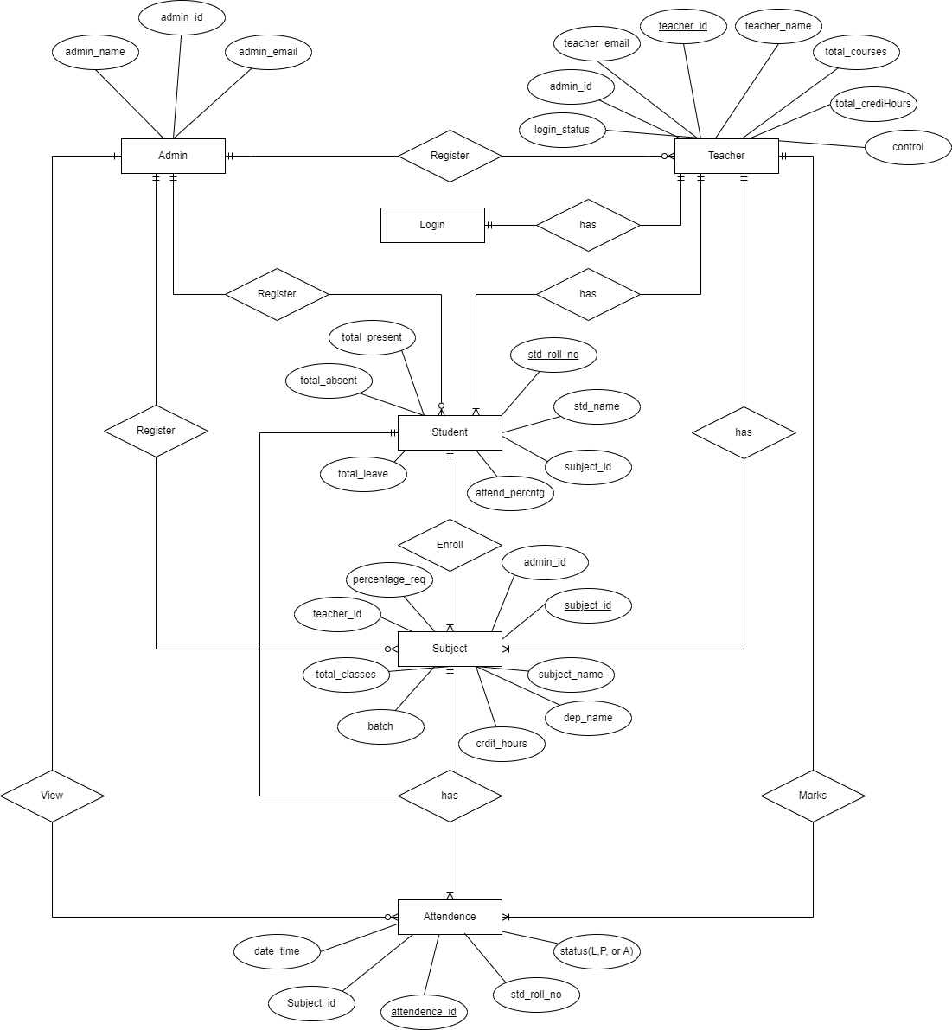

Figure 3.1 System ERD of Attendance Manager App

## **3.7.2 Data Flow Diagram (DFD):**

A Data Flow Diagram (DFD) for Attendance Manager App is a graphical representation that depicts the flow of data within a system. It illustrates the processes, data sources, data destinations, and data flows involved in the system. DFDs are commonly used in system analysis and design to represent the data movement and processing within a system.

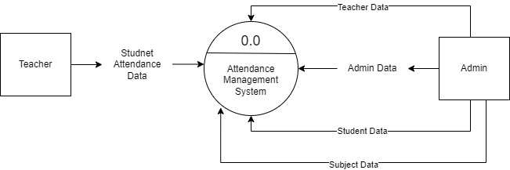

### **3.7.2.1 0 Level DFD:**

Figure 3.2 Level 0 DFD

### **attendance lvl 1.drawio.png**

### **3.7.2.2 Level 1 DFD:**

Figure 3.3 Level 1 DFD

# **3.8 Use Case Diagram (UC):**

A Use Case is a representation of a specific interaction between a system (software application) and its users. It describes the steps or actions that a user or actor takes to achieve a particular goal or outcome with the system.

In software development and system analysis, Use Cases are used to capture functional requirements and define the behavior of the system from a user's perspective. They help identify the system's functionalities, the actors (users or external systems) involved, and the various scenarios or paths that the user and system can follow during the interaction.

For our Attendance Manager System, the primary and secondary actors for the Use Case diagram can be identified as follows:

**Primary Actors:**

**Administrator:** The system administrator who has overall control and management of the Attendance Manager App. They perform tasks like student and teacher registration, subject assigning, and report generation.

**Secondary Actors:**

**Teacher:** The teachers who use the Attendance Manager App perform tasks like marking Student attendance and Export Attendance.

## **3.8.1 System Use Case Diagram:**

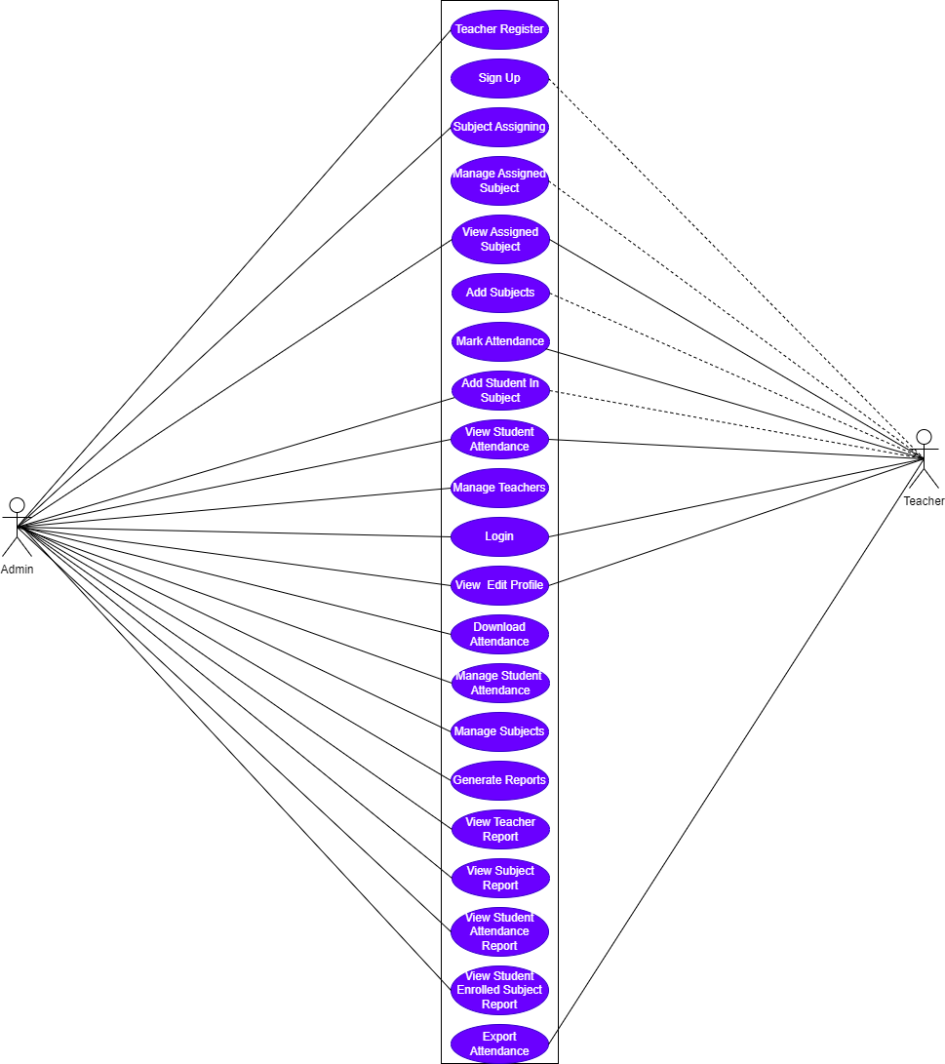

Figure 3. System Use Case Diagram

## **3.8.2 Admin Use Case Diagram:**

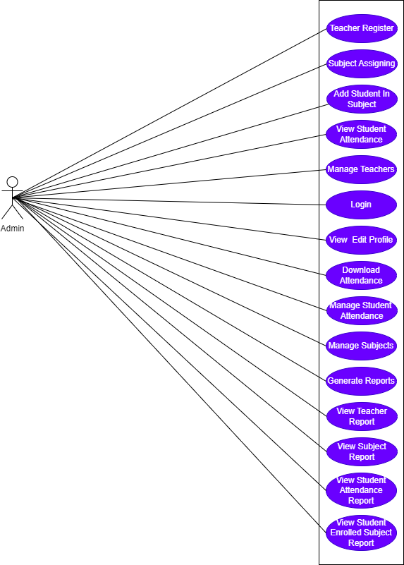

Figure 3. Admin Side Use Case Diagram

## **3.8.3 Teacher Use Case Diagram:**

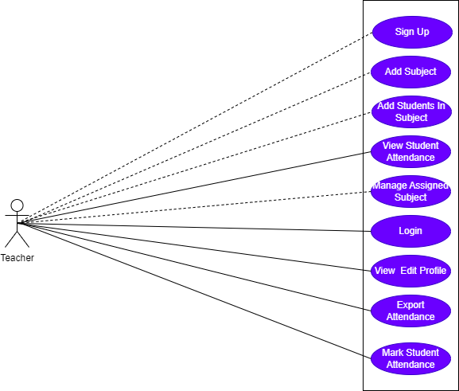

Figure 3. 6 Teacher Side Use Case Diagram

# 

# **Chapter 4**

# **Output Of The Application**

# **4.1 Splash Screen**

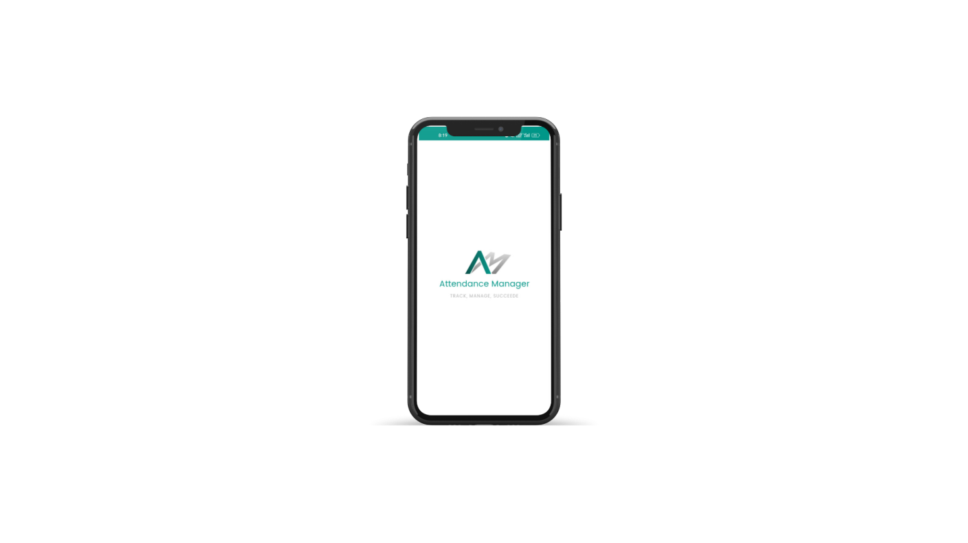

Welcome Screen is the starting screen of the app

# **4.2 Authentication Screen**

Authentication screen ensures the privacy of the users. They can use this app protectively.

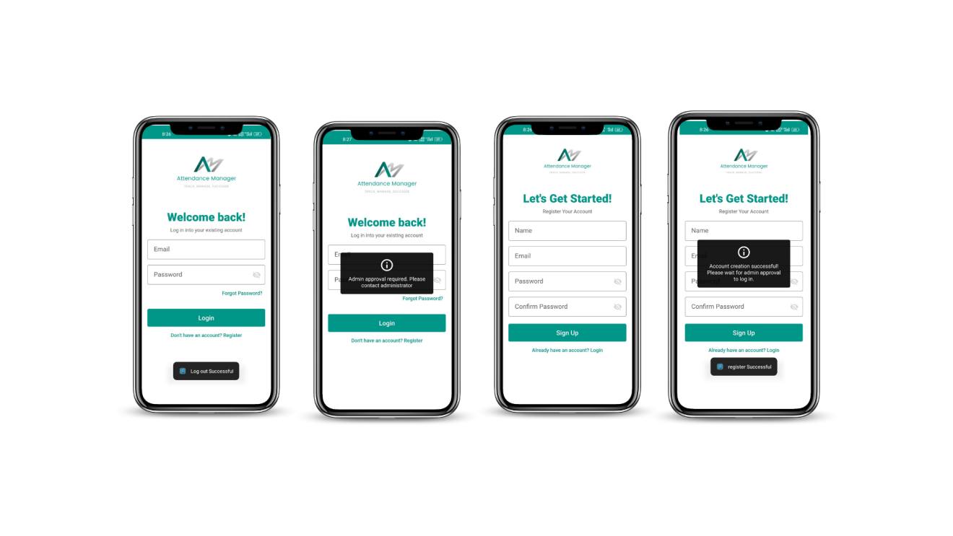

# **4.3 Home Screen**

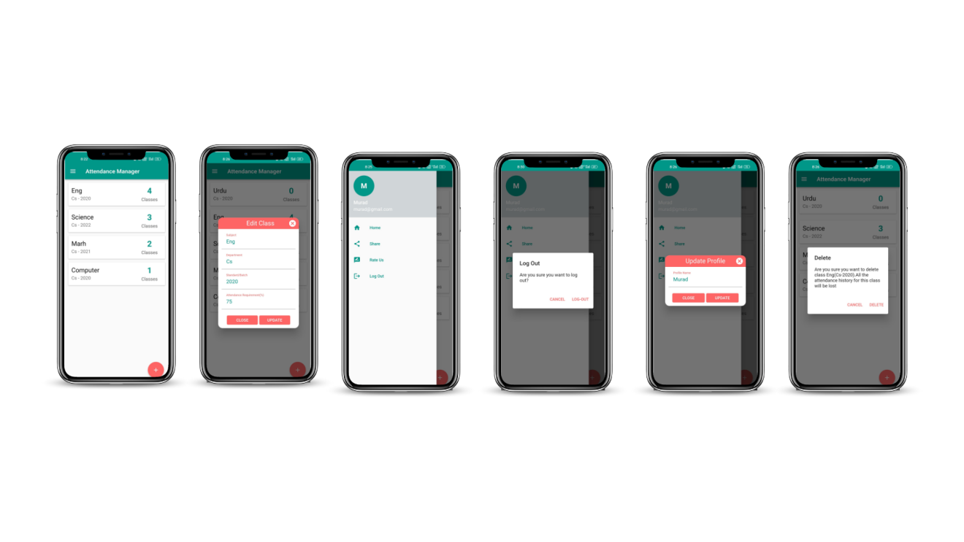

# **4.4 Register Subject/Course Screen**

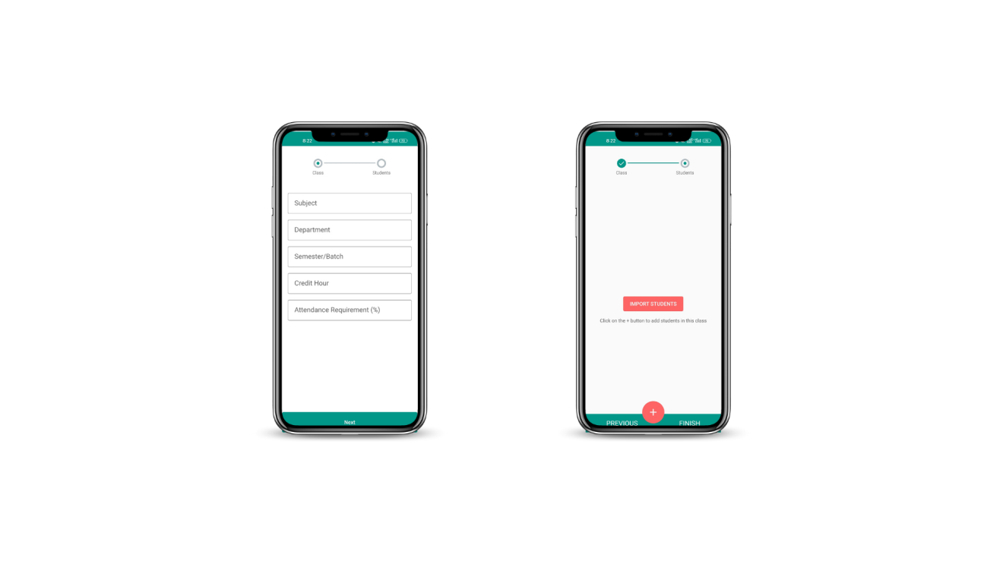

# **4.5 Register Student Screen**

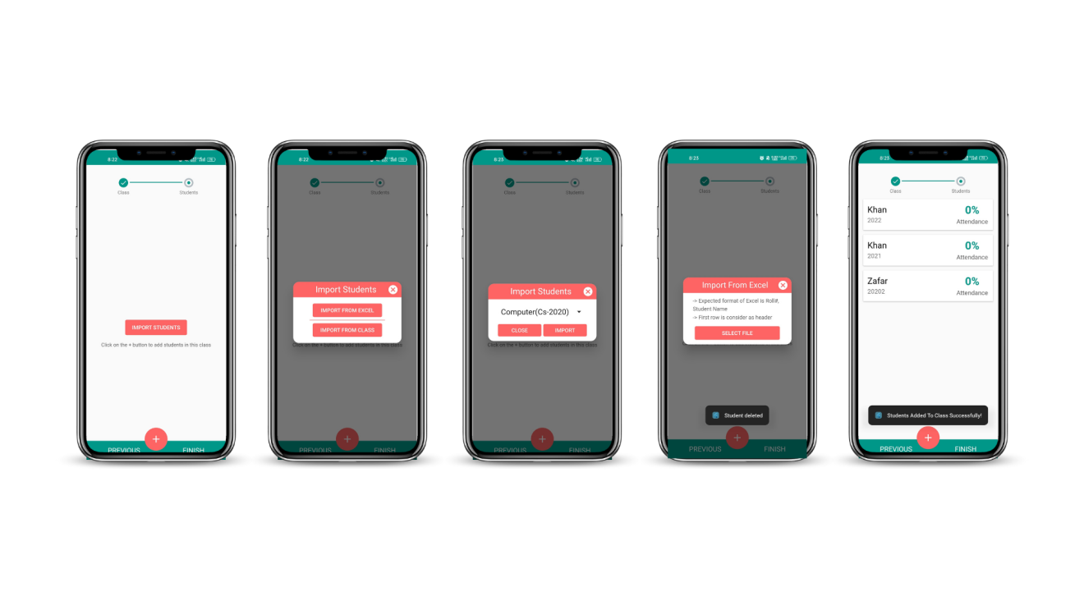

# **4.6 Student Details Screen**

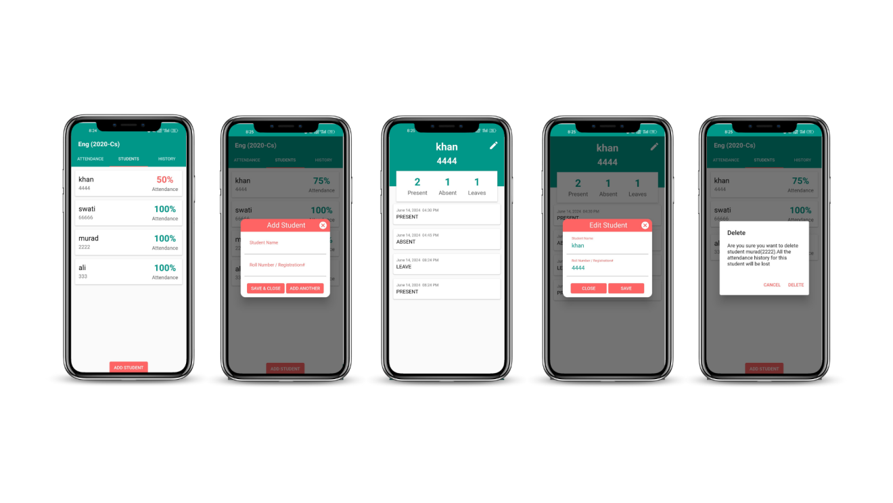

# **4.7 Attendance Screen**

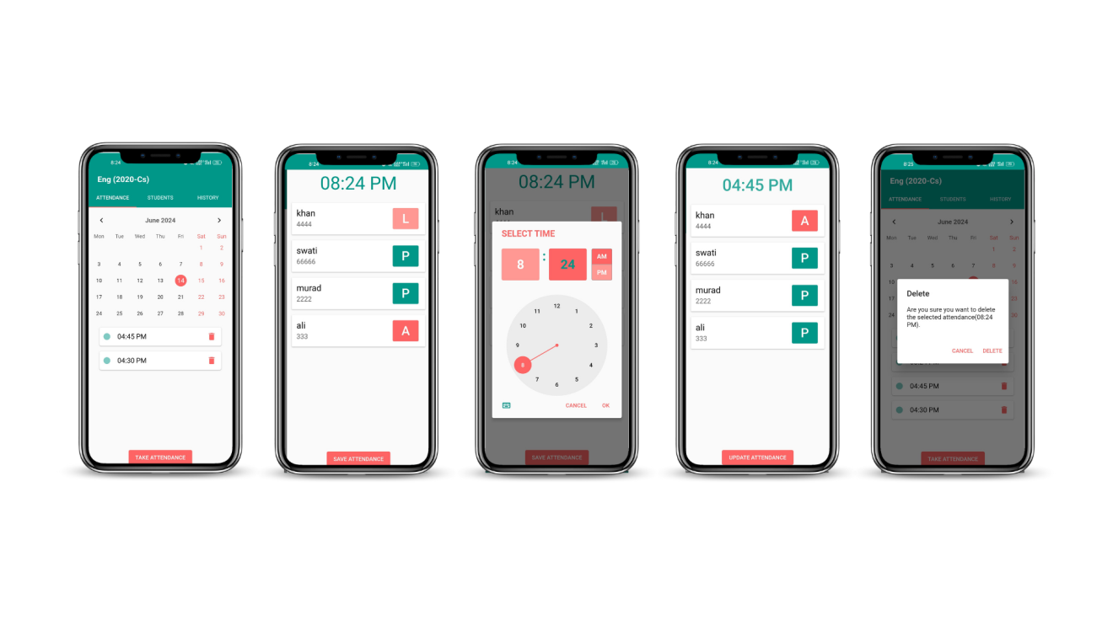

# **4.8 History Screen**

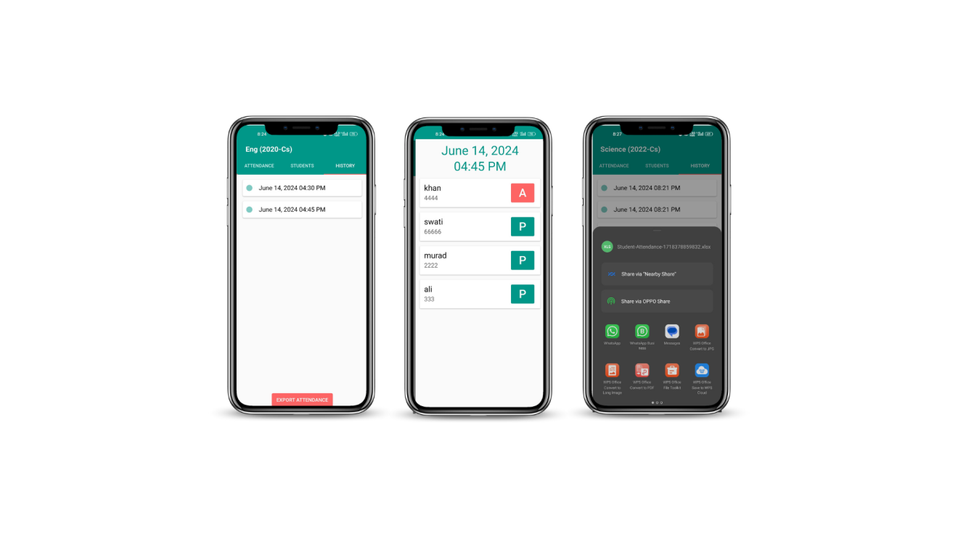

# **4.9 Exported Excel Sheet**

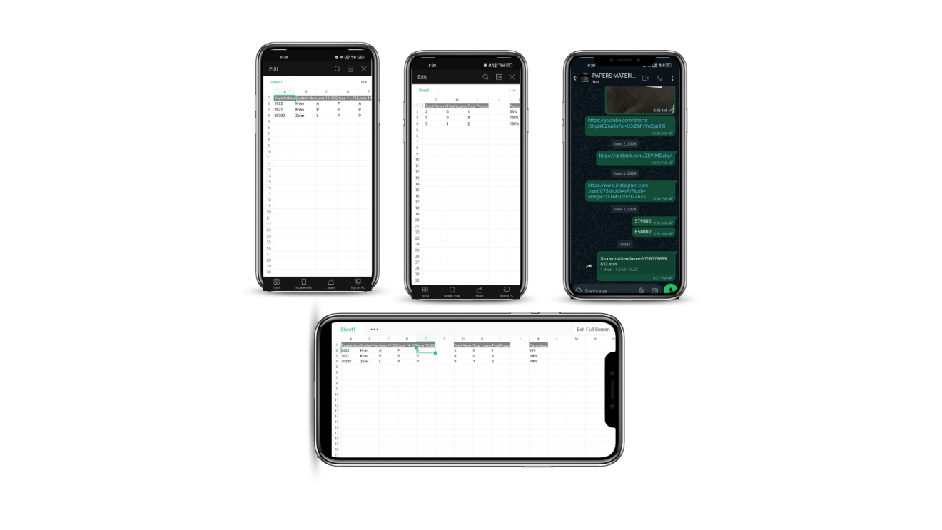

# **4.10 Webapp Hotels Screen**

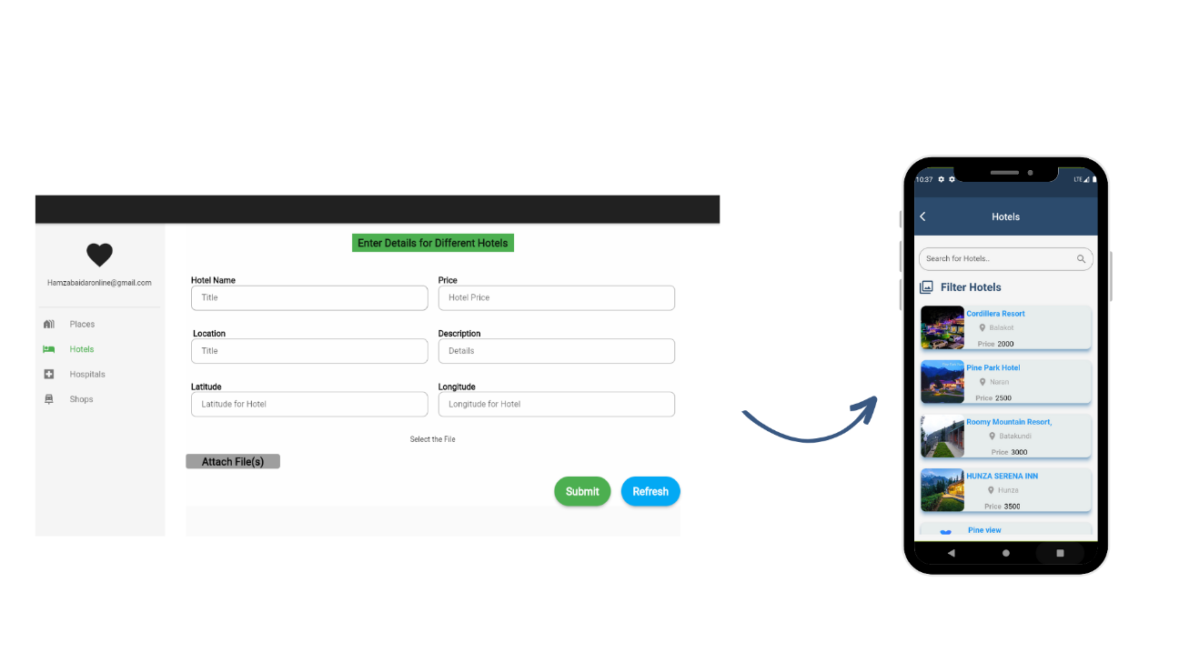

At Webapp Hotel screen admin can add and deletedifferent places for users

# **4.11 Webapp Hospitals Screen**

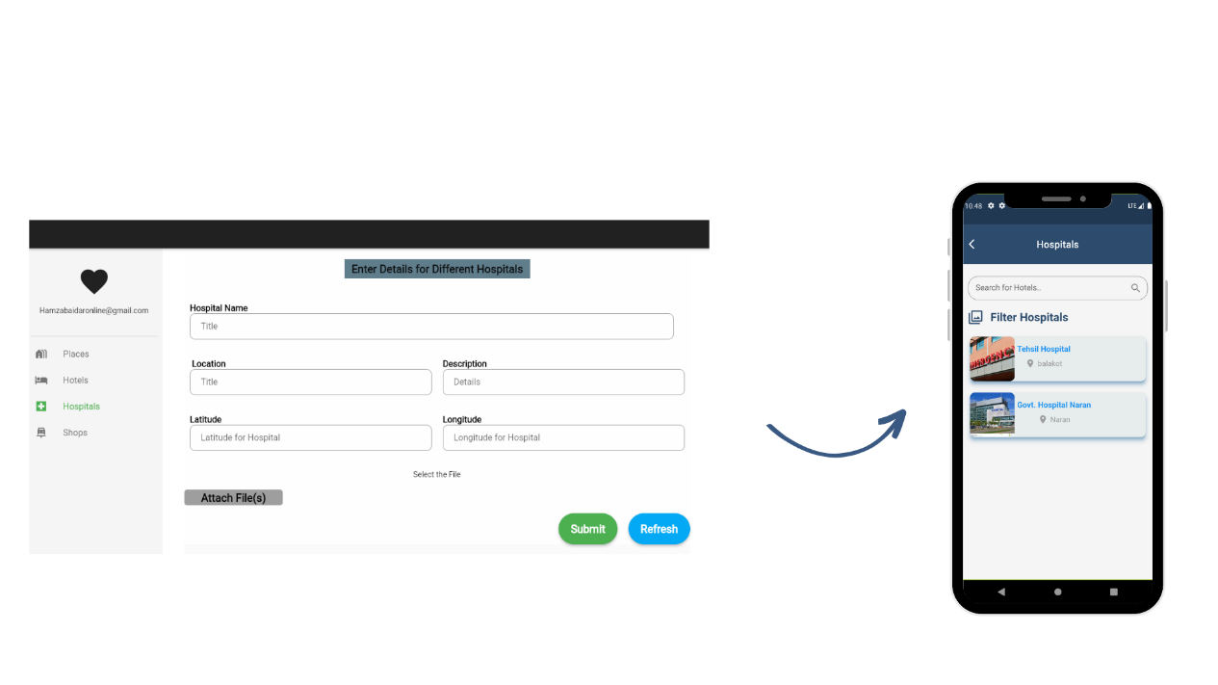

At Webapp Hospitals screen admin can add and deletedifferent places for users

# **Chapter 5:**

# **Testing**

# **5.1 Testing And Its Types**

The testing phase of the software development lifecycle is crucial to ensure the quality, functionality, and reliability of the proposed system. It involves systematically evaluating the system's behavior, performance, and security to identify any defects or issues that may affect its proper functioning. Testing is essential to verify that the system meets the specified requirements, meets user expectations, and operates as intended.

The objective of the testing phase is to validate the system against the defined requirements and specifications, ensuring that it functions correctly and provides a seamless user experience. Testing helps in uncovering errors, bugs, or inconsistencies in the system, allowing developers to rectify them before the system is deployed for actual use.

Testing activities are performed at different levels, including unit testing, integration testing, system testing, and user acceptance testing. Each level focuses on testing specific aspects of the system and ensures that all components work together harmoniously.

The testing process involves designing test cases, executing them, and comparing the actual system behavior with the expected results. It also involves measuring system performance, assessing usability, and evaluating security measures. By conducting thorough testing, developers can identify and address any issues that may arise during system operation, leading to a more robust and reliable software product.

## **5.1.1 Unit Testing**

Unit testing is a fundamental testing approach that focuses on evaluating the individual components or units of the software system in isolation. In the context of our project, unit testing involves testing the functionalities and behaviors of specific modules, classes, or methods within the attendance manager app.

The purpose of unit testing is to ensure that each unit of the software functions as expected and produces the desired output. It helps in identifying and fixing any defects or errors at an early stage, minimizing the chances of these issues propagating to higher levels of testing or impacting the overall system performance.

In our project, unit testing is performed using a testing framework such as JUnit. Each unit is tested independently, simulating different scenarios and input conditions to verify its functionality. The unit tests are designed to cover various aspects, including boundary cases, exception handling, and edge cases, to ensure comprehensive test coverage.

For example, in the attendance module, unit tests may be created to validate functions such as adding a new attendance record, retrieving attendance information, and updating attendance details. The tests would verify that the functions correctly handle different inputs, such as valid and invalid data, and produce the expected outcomes.

During unit testing, test cases are designed to assess the behavior of the unit in different scenarios, including both positive and negative test cases. The test cases are executed, and the actual results are compared against the expected results. Any discrepancies or failures indicate the presence of defects that need to be addressed.

Unit testing not only helps in identifying bugs or errors but also facilitates code refactoring, as it encourages developers to write modular, reusable, and maintainable code. It promotes code quality, improves software reliability, and contributes to overall system stability.

By conducting thorough unit testing, we ensure that each individual unit of our attendance manager functions correctly, adheres to the defined specifications, and integrates seamlessly with other components of the system. This level of testing provides a solid foundation for the subsequent integration testing and system testing phases, ensuring a robust and reliable software product.

## **5.1.2 Widget Testing**

Widget testing is a testing approach that focuses on evaluating the functionality and behavior of user interface (UI) components, known as widgets, within a software application. In the context of our project, widget testing involves testing the UI elements and their interactions within the attendance manager app.

The purpose of widget testing is to ensure that the UI components, such as buttons, menus, forms, and other interactive elements, function correctly and provide the intended user experience. It involves validating the visual appearance, responsiveness, and usability of these widgets.

During widget testing, various scenarios are simulated to assess the functionality of the UI components. For example, in the attendance module, widget tests may be designed to verify the behavior of buttons for marking attendance, navigating through different screens, or interacting with pop-up dialogs. These tests ensure that the widgets respond correctly to user interactions and produce the expected outcomes.

Widget testing also involves testing the UI layout and responsiveness across different screen sizes, resolutions, and orientations. It ensures that the app's UI elements adapt and display properly on various devices, providing a consistent and optimal user experience.

Additionally, widget testing encompasses the verification of user input validations, error handling, and the synchronization between UI components and underlying data. For instance, widget tests may validate that appropriate error messages are displayed when invalid data is entered into input fields or that changes made in one widget are correctly reflected in other related widgets.

By conducting comprehensive widget testing, we can identify and rectify any UI-related issues, such as unresponsive buttons, layout inconsistencies, or incorrect user feedback. This testing approach helps ensure that the UI components of our tourism app meet the desired standards of functionality, aesthetics, and usability.

Widget testing is an essential part of the overall testing strategy for our project, as it focuses on the user-facing aspects of the app. By validating the UI components, we can provide a seamless and engaging user experience, enhancing the overall quality of our tourism app and increasing user satisfaction.

# **5.2 Purpose of Testing:**

Testing is performed to identify and rectify any defects or issues in the software system.

It helps ensure that the system meets the specified requirements and functions correctly.

Testing provides confidence in the reliability, functionality, and usability of the system.

# **5.3 Testing Techniques**

## **5.3.1 White Box Testing:**

White box testing is a testing technique that focuses on examining the internal structure and logic of the software application. In the context of our attendance manager app, white box testing involves testing the individual components and functions of the codebase to ensure their correctness and proper integration. This technique enables us to verify the accuracy of the internal calculations, data flow, and control flow within the system. By conducting white box testing, we can identify any coding errors, boundary conditions, or potential defects that may affect the functionality of the app.

## **5.3.2 Black Box Testing:**

Black box testing is a software testing technique where the tester examines the functionality of the software without any knowledge of its internal structure or code implementation. It focuses on validating the system's behavior based on the specified requirements and inputs, without considering how the system processes the inputs or produces the outputs. Test cases are designed to cover different scenarios and user interactions, aiming to identify any discrepancies between the expected and actual results. Black box testing helps ensure that the app functions correctly from a user's perspective and meets the desired functionality. By simulating various user interactions and input combinations, we can uncover potential bugs, usability issues, and inconsistencies within the app.

## **5.3.3 Branch Testing:**

Branch testing is a software testing technique that focuses on examining the different branches or decision points within the code. It aims to ensure that all possible branches of a program are tested at least once. Test cases are designed to cover both true and false conditions of conditional statements, loops, and other branching constructs. By testing each branch individually, we can identify any logical errors or missing code paths that may result in unexpected behavior. Branch testing helps improve code coverage and ensures that all possible execution paths are tested, reducing the risk of undetected bugs or functional issues within the system.

## **5.3.4 Functional Testing:**

Functional testing is a type of software testing that focuses on verifying the functional requirements of the system. It involves testing the individual functions and features of the software to ensure that they work as intended. Test cases are designed to cover different scenarios and user interactions to validate the expected behavior of the system. Functional testing aims to identify any functional defects, such as incorrect calculations, missing or inaccurate data, or improper system responses. By conducting functional testing, we can ensure that the software meets the desired functionality and performs as expected, providing a reliable and satisfactory user experience.

## **5.3.5 Usability Testing:**

Usability testing evaluates the user-friendliness and ease of use of the software. It focuses on assessing how well the system meets the needs and expectations of the users. Usability tests are conducted with representative users who perform typical tasks and provide feedback on their experience. The goal is to identify any usability issues, such as confusing navigation, unclear instructions, or inefficient workflows. By conducting usability testing, we can make necessary improvements to enhance the overall usability and user satisfaction of the software. It helps in creating a more intuitive and user-friendly interface, improving user engagement and adoption of the system.

## **5.3.6 Performance Testing:**

Performance testing evaluates the system's responsiveness, scalability, and stability under different workload conditions. It measures the system's ability to handle a large number of users, process requests efficiently, and maintain acceptable response times. Performance tests simulate realistic scenarios and stress the system by generating high user loads. The tests assess factors like response time, throughput, resource utilization, and scalability. By conducting performance testing,we can identify performance bottlenecks, optimize system resources, and ensure that the software performs reliably under varying workloads. This helps in delivering a high-performance and efficient system to users, providing a smooth and seamless experience.

## **5.3.7 Security Testing:**

Security testing focuses on identifying vulnerabilities and weaknesses in the system's security measures. It aims to ensure the protection of sensitive data, prevent unauthorized access, and safeguard against potential threats. Security tests evaluate the system's resilience to attacks, such as SQL injection, cross-site scripting, and unauthorized access attempts. The tests analyze authentication mechanisms,data encryption, access controls, and compliance with security standards. By conducting security testing, we can identify and address potential security loopholes, strengthen the system's security posture, and provide a secure environment for users to interact with the software.

## **5.3.8 Integration Testing:**

Integration testing verifies the seamless integration and interaction between different components or modules of the system. It aims to ensure that the individual components work together harmoniously and exchange data correctly. Integration tests validate the interoperability of various modules and detect any compatibility issues or dependencies. By simulating real-world scenarios and testing the integration points, we can identify and resolve any inconsistencies, communication errors, or data mismatches. Integration testing helps ensure the smooth functioning of the entire system, promoting reliable data flow and efficient collaboration between different components.

## **5.3.9 Regression Testing:**

Regression testing is performed to validate that the modifications or enhancements made to the system do not introduce new defects or negatively impact existing functionalities. It involves retesting previously tested functionalities to ensure they still function as expected after changes are implemented. By running a set of predefined test cases, regression testing helps identify any unintended side effects or regression issues that may arise due to code modifications. It helps maintain the overall stability and reliability of the system by ensuring that existing features continue to work correctly, even in the presence of updates or changes.

## **5.3.10 User Acceptance Testing (UAT):**

User Acceptance Testing is conducted to verify whether the developed system meets the requirements and expectations of the end-users. It involves real users or representatives from the target audience performing various tests to validate the system's usability, functionality, and overall user experience. UAT focuses on assessing the system from a user's perspective and ensuring that it aligns with their needs and preferences. By involving end-users in the testing process, UAT helps gather valuable feedback and identifies any areas that require improvement or refinement before the final release. Its primary goal is to ensure that the system is ready for deployment and adoption by the intended users.

### **Chapter 6**

### **Future Work and Project Conclusion**

# **6.1 Conclusion**

The project's conclusion marks the culmination of our efforts and provides an opportunity to reflect on the outcomes and future prospects. Throughout the project, we successfully developed the Attendance Manager App tailored to enhance attendance management for teachers and administrators.

The implementation of the proposed system has shown promising results and has addressed the challenges faced by existing attendance management practices. The app provides users with a comprehensive platform to register courses, add students, mark attendance, manage courses, and generate detailed reports.

During the development process, we utilized various technologies, including Firebase for backend services and Flutter for the front-end interface. The system architecture, user interface design, and database structure were carefully crafted to ensure efficiency, scalability, and a seamless user experience.

In terms of testing, we employed a range of techniques such as unit testing, widget testing, and usability testing to verify the functionality, reliability, and user-friendliness of the app. Additionally, performance testing and security testing were conducted to ensure optimal performance and protect user data.

While the project has achieved its primary objectives, there are opportunities for future work and improvement. One potential avenue is to expand the app's features to include more detailed analytics on student performance and attendance trends. Additionally, incorporating features such as real-time notifications for attendance updates and integrating more interactive user interfaces can further enhance the app's value.

In conclusion, the project has successfully addressed the challenges in existing attendance management practices through the development of a user-friendly and informative Attendance Manager App. The app provides users with a convenient platform to manage classroom activities, access accurate information, and improve overall efficiency. The project has demonstrated the potential of technology in transforming classroom management and has opened avenues for further advancements and innovations in the field.

# **6.2 Future Work**

In addition to the achievements and outcomes of the project, there are several areas of future work that can be explored to further enhance the attendance manager app and its impact on educational institutions. These potential future endeavors aim to improve various aspects of the app and expand its capabilities. Some key areas of future work include:

* **Expansion of Features:** The app can be expanded to include more comprehensive attendance-related features, such as tracking tardiness, early departures, and automated notifications to parents or guardians. By incorporating these features, the app can provide a more holistic attendance management solution.
* **Integration with School Management Systems**: Integrating the app with existing school management systems can facilitate seamless data sharing and synchronization. This can help streamline administrative processes, reduce redundancy, and improve overall efficiency in managing student records and attendance.
* **Enhanced Reporting and Analytics:** Implementing advanced reporting and analytics features can provide valuable insights into attendance patterns and trends. This can help educators and administrators identify issues early, track student performance, and make data-driven decisions to improve attendance and engagement.
* **Mobile App Development:** Developing a dedicated mobile app for both IOS and Android platforms can provide users with greater accessibility and convenience. This can include features such as push notifications for attendance updates, real-time attendance tracking, and easy access to attendance reports on the go.
* **Integration with Biometric Systems:** Integrating biometric systems such as fingerprint or facial recognition can enhance the accuracy and security of the attendance tracking process. This can help eliminate issues related to manual entry errors and ensure that attendance records are accurate and reliable.
* **Collaboration with Educational Authorities:** Building strong partnerships and collaborations with educational authorities and relevant stakeholders can contribute to the sustainability and growth of the app. This can involve obtaining updated data, forging partnerships for promotional activities, and fostering a mutually beneficial relationship to support the educational ecosystem.
* **Multi-language Support:** Expanding the app's language support to include multiple languages can cater to a broader international audience. By offering translations and localized content, the app can become more accessible and appealing to users from different linguistic backgrounds.
* **Accessibility Features:** Implementing accessibility features such as screen reader support, voice commands, and adjustable font sizes can ensure that the app is inclusive and usable for individuals with disabilities. This can enhance the overall user experience and make the app accessible to a wider range of users.
* **Enhanced Security Measures:** Continuously improving the app's security features can ensure that user data is protected against potential threats. This can include implementing advanced encryption methods, regular security audits, and staying updated with the latest security protocols.
* **Social Connectivity:** Enhancing the app's social connectivity features can enable users to connect with classmates, join study groups, and engage in social interactions. This can foster a sense of community, encourage knowledge sharing, and provide opportunities for collaboration and support among students.

By focusing on these areas of future work, we can further develop the attendance manager app to meet the evolving needs of educational institutions, enhance user experience, and contribute to the overall effectiveness of attendance management in schools and colleges.

### **REFERENCES**

1. <https://pub.dev/>
2. <https://github.com/topics>
3. <https://firebase.flutter.dev/docs/auth/start/?gclid=CjwKCAjwm4ukBhAuEiwA0zQxk-s3qLx2G8opDrB-giMohs6Uqn_TQxdYNv9_o3hNG0v3Uvgy9jU9_xoChcwQAvD_BwE&gclsrc=aw.d>